NEW! Advisor’s Mental Health Services Module
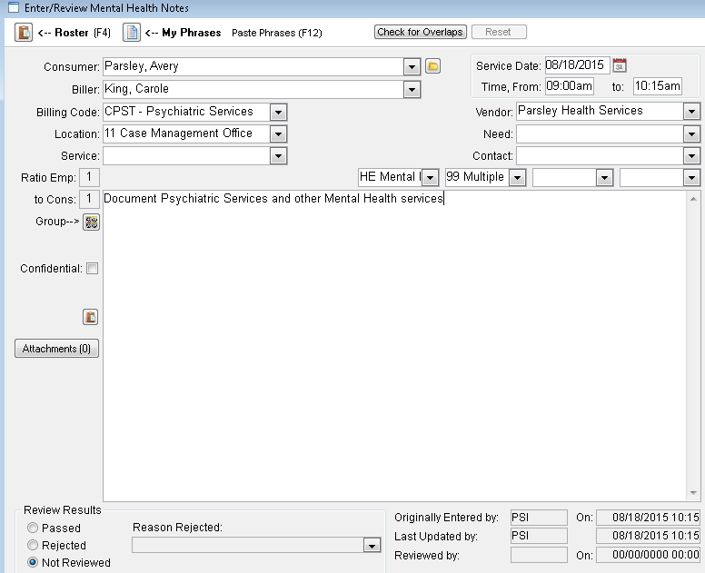
Attach Pertinent Documentation
Key Features:
- Document Mental Health Services
- Create and Submit Associated Claims
- Manage Claims Via Advisor’s Billing/Receivables Module
- Available Qtr. 1 -2016

